ISA Draft 95.00.05

Enterprise - Control System Integration
Part 5: Business to Manufacturing Transactions
Draft 3
January 2005
This document is a draft that represents work being done by an ISA Standards Committee leading to the development of an ISA Standard. ISA grants permission to anyone to reproduce and distribute copies of this draft ISA standard, in whole or in part, but only for the following purposes and only as long as the recipient is not charged any fee for the copy (nor may the copy be included as part of a package with other materials or presentations for which a fee is charged):
- Review of and comment on the draft standard;
- Provide to others for review and comment;
- Promotion of the standard; or
- Informing and educating others about the standard.
In addition, all copies must reproduce a copyright notice as follows:
© Copyright 2004 ISA. All rights reserved. Reproduced and distributed with permission of ISA.
ISA reserves all other rights to the draft standard. Any other reproduction or distribution without the prior written consent of ISA is prohibited.
The reader is cautioned that this document has not been approved and cannot be presumed to reflect the position of ISA or any other committee, society, or group. Although every effort has been made to ensure accuracy, neither ISA, members of the S&P Department, nor their employers shall be held liable for errors or limitations.


ISA Draft 95.00.05, Enterprise-Control System Integration, Part 5: Business to Manufacturing Transactions
ISBN: -to-be-assigned-

Copyright © 2005 by the Instrumentation, Systems and Automation Society. All rights reserved. Not for resale. Printed in the United States of America.
ISA
67 Alexander Drive
P. O. Box 12277
Research Triangle Park, NC 27709 USA

NOTE: Some of the work in this document is based on the work of the Open Applications Group, Inc. All references to the Open Applications Group, OAGIS, and BODs remains the property of the Open Applications Group and its members. The Open Applications Group OAGIS is a royalty-free standard and the license grants any user to build products and base derivative works on OAGIS, as long as the intellectual property is acknowledged to belong to OAGi and its members. For more information on the Open Applications Group and OAGIS go to www.openapplications.org.
Preface

This preface, as well as all footnotes and annexes, is included for information purposes and is not part of ISA 95.00.05.
This document has been prepared as part of the service of ISA, the Instrumentation, Systems and Automation Society, toward a goal of uniformity in the field of instrumentation. To be of real value, this document should not be static but should be subject to periodic review. Toward this end, the Society welcomes all comments and criticisms and asks that they be addressed to the Secretary, Standards and Practices Board; ISA; 67 Alexander Drive; P. O. Box 12277; Research Triangle Park, NC 27709; Telephone (919) 549-8411; Fax (919) 549-8288; E-mail: standards@isa.org.
The ISA Standards and Practices Department is aware of the growing need for attention to the metric system of units in general, and the International System of Units (SI) in particular, in the preparation of instrumentation standards. The Department is further aware of the benefits to USA users of ISA standards of incorporating suitable references to the SI (and the metric system) in their business and professional dealings with other countries. Toward this end, this Department will endeavor to introduce SI-acceptable metric units in all new and revised standards, recommended practices, and technical reports to the greatest extent possible. Standard for Use of the International System of Units (SI): The Modern Metric System, published by the American Society for Testing & Materials as IEEE/ASTM SI 10-97, and future revisions, will be the reference guide for definitions, symbols, abbreviations, and conversion factors.
It is the policy of ISA to encourage and welcome the participation of all concerned individuals and interests in the development of ISA standards, recommended practices, and technical reports. Participation in the ISA standards-making process by an individual in no way constitutes endorsement by the employer of that individual, of ISA, or of any of the standards, recommended practices, and technical reports that ISA develops.
CAUTION:
ISA adheres to the policy of the American National Standards Institute with regard to patents. If ISA is informed of an existing patent that is required for use of the standard, it will require the owner of the patent to either grant a royalty-free license for use of the patent by users complying with the standard or a license on reasonable terms and conditions that are free from unfair discrimination.
Even if ISA is unaware of any patent covering this Standard, the user is cautioned that implementation of the standard may require use of techniques, processes, or materials covered by patent rights. ISA takes no position on the existence or validity of any patent rights that may be involved in implementing the standard. ISA is not responsible for identifying all patents that may require a license before implementation of the standard or for investigating the validity or scope of any patents brought to its attention. The user should carefully investigate relevant patents before using the standard for the user’s intended application.
However, ISA asks that anyone reviewing this standard who is aware of any patents that may impact implementation of the standard notify the ISA Standards and Practices Department of the patent and its owner.
Additionally, the use of this standard may involve hazardous materials, operations or equipment. The standard cannot anticipate all possible applications or address all possible safety issues associated with use in hazardous conditions. The user of this standard must exercise sound professional judgment concerning its use and applicability under the user’s particular circumstances. The user must also consider the applicability of any governmental regulatory limitations and established safety and health practices before implementing this standard.

The following individuals served as voting members of ISA SP95 during the preparation of Part 5:
Name | Company
Keith Unger* | Rockwell Software
William H. Bosler ** | Texas Consultants Inc.
Donald Clark ** | Invensys
Dennis Brandl *** | BR&L Consulting, Inc.
Chris Monchinski**** | Automated Control Concepts
Gary Addison | Lyondell – Equistar
David J. Adler | Eli Lilly & Co
Lynn W. Craig | MAA Inc
Eric C. Cosman | Dow Chemical
Paresh Dalwalla | OpteBiz
Dennis Delaney | Accenture
Em delaHostria~ | Rockwell Automation
Stefano Dighero | Siemens
David Emerson | Yokogawa
Charlie Gifford | GE Fanuc America
Les Hastings | ProsCon Ltd
Gavan Hood | Rockwell Automation
Jay Jeffreys~ | Wonderware/Invensys
Charlotta Johnsson | Siemens & Lund Institute of Technology
Alan Johnston | MIMOSA
Marc Leroux | ABB Inc
Richard Martin | Aspen Technology
Yasuyuki Nishioka | Hosie University
Saroj Patnaik | Emerson Process Automation
Costantino Pipero | Invensys - Wonderware
Anne Poorman~ | ABB Inc.
Leif Poulson | Novo Nordisk Engineering
Leon Steinocher | Fluor Enterprises
Swarandeep Singh~ | ABB AS
Jean Vieille | Consultant
Ray Walker | DuPont
Theodore Williams | Purdue University

* Chairman
** Vice Chairman
*** Editor
**** Secretary
~ Alternate

The following individuals also served as active members of ISA-SP95 during the preparation of Part 5:
Name | Company
Ken Bever | MIMOSA
David Connelly | Open Applications Group
David Cornel | Procter & Gamble
Russ Dickenson | Dow Chemical
Llorenç Domingo | Aspen Technology
Steve Downs | Applied Creative Technologies
Daniel G. Dziadiw | Schering-Plough
Joe Faccenda | Aspen Technology
Christine Hermetet-Filez | AFNOR
Kevin Fitzgerald | Invensys
Tony Gallo | Adelphia
Alistar Gillanders | Aspen Technology
Steve Graham | Dow Chemical
Graeme Hall | Aspen Technology
Bill Hawkins | HLQ
Girish Joglekar | Purdue University
Hansil Kim | University of Ulsan
Eugene Lambert | Wunderlich-Malec
Jim Luth | OPC Foundation
Kirhen Manjunath | Honeywell
Jean-Jacques Michel | IDPI Conseil
Thorsten Ruehl | Camstar
Nate Schallert | Eli Lilly & Co
Paul Schiller | BP America
Bianca Scholten | TWP
Dave Shorter | IT Focus
Bryan Singer | Rockwell Automation
Arne Svendsen | Arla Foods
Jason Toschlog | Flexware Inovation
Gregory Winchester | NEMA
Chunhua Zhao | Purdue University

Contents

FOREWORD 10
INTRODUCTION 11
1. Scope 12
2. Normative references 12
3. Definitions and abbreviations 12
4. Transaction Model 13
4.1 Introduction 13
4.2 Exchanged Messages 13
4.2.1 Application identification area 13
4.2.2 Data Area 14
4.2.3 Transaction verbs 14
4.2.4 Transaction nouns 15
4.2.5 Transaction documents 16
4.3 Error Handling 17
4.4 Request and response communication 19
4.4.1 GET individual object 19
4.4.2 ADD an object 21
4.4.3 Object identification in an ADD 21
4.4.4 CHANGE an object 22
4.4.5 Object identification in a CHANGE 22
4.4.6 CANCEL an object 22
4.4.7 Object identification in a CANCEL 23
4.5 Publish and subscribe transactions 23
4.5.1 PROCESS an object 23
4.5.2 SYNC information 24
4.5.3 CONFIRM an exchange 25
4.5.4 SYNC ADD an object 25
4.5.5 Object identification in a SYNC ADD 26
4.5.6 SYNC CHANGE an object 26
4.5.7 Object identification in a SYNC CHANGE 26
4.5.8 SYNC DELETE an object 26
4.5.9 Object identification in a SYNC DELETE 27
5. Transactions 28
5.1 Personnel model 28
5.1.1 Personnel Class 28
5.1.2 Person 29
5.1.3 Qualification Test 30
5.2 Equipment 30
5.2.1 Equipment Class 31
5.2.2 Equipment 32
5.2.3 Capability Test 33
5.3 Maintenance 33
5.3.1 Maintenance Requests 33
5.3.2 Maintenance Response 34
5.3.3 Maintenance Work Order 34
5.4 Material 35
5.4.1 Material Class 36
5.4.2 Material Definition 36
5.4.3 Material Lot 37
5.4.4 QA Test 38
5.5 Process Segment 38
5.6 Production Capability 39
5.7 Product Definition 41
5.8 Production Schedule 41
5.9 Production Performance 42
6. Defined Transactions 43
Annex A – Questions on the use of transactions 44
Annex B – Bibliography and References 45

Figures

Figure 1 - Typical exchanged data set 13
Figure 2 - Typical application identification information 14
Figure 3 - Sample of exchanged documents in a transaction 17
Figure 4 - Confirm verb 18
Figure 5 - Confirm Message 19
Figure 6 – GET and SHOW transaction 19
Figure 7- GET with wildcard and SHOW response 20
Figure 8 - GET and SHOW transaction with a CONFIRM always 21
Figure 9 - ADD with a Confirm 21
Figure 10 - CHANGE command with confirm OnError set 22
Figure 11 - CANCEL command 23
Figure 12 - PROCESS Command 24
Figure 13- SYNC CHANGE transaction with Confirm set 25
Figure 14 - SYNC ADD transaction 25
Figure 15 - SYNC CHANGE transaction with CONFIRM set 26
Figure 16 - SYNC DELETE transaction with no CONFIRM 27
Figure 17 - Object grouping for the personnel model 28
Figure 18 - Object grouping for the equipment model 31
Figure 19 - Object grouping for the material model 35

Tables
Table 1 - Defined verbs 15
Table 2 - Defined nouns 16
Table 3 – Confirmation request options 18
Table 4 – Acknowledge additional element 25
Table 5 - Personnel class Get definitions 30
Table 6 - Person Get definitions 30
Table 7 - Qualification Test Get definitions 31
Table 8 - EquipmentClass Get definitions 32
Table 9 - Equipment Get definitions 33
Table 10 - Capability Test Get definitions 34
Table 11 - Maintenance Request Get definitions 34
Table 12 - Maintenance Response Get definitions 35
Table 13 - Maintenance Work Order Get definitions 35
Table 14 - Material Class Get definitions 37
Table 15 - Material Definition Get definitions 38
Table 16 - Material Lot Get definitions 38
Table 17 - QA Test Get definitions 39
Table 18 – Process Segment Get definitions 40
Table 19 – Production Capability Element definitions for GET verb 40
Table 20 – Product Definition Get definitions 42
Table 21 – Production Schedule definitions for GET verb 42
Table 22 – Production Performance definitions for GET verb 43
Table 23- Verb and noun relationship 44

Enterprise-Control System Integration
Part 5: Business to Manufacturing Transactions

FOREWORD
This standard is Part 5 of a multi-part set of standards that defines the interfaces between enterprise activities and control activities.
Clause 4 is normative. It describes the transaction model used and the verbs used in the transactions.
Clause 5 is normative. It defines the transactions and verbs for each object class.
Clause 6 is normative. It defines the mapping of defined verbs and nouns in the transactions.
Annex A is informative. It contains a series of questions and answers regarding the use of the standard.
As currently envisioned, ANSI/ISA-95 consists of the following parts under the general title Enterprise/Control System Integration:
- Part 1: Models and terminology
- Part 2: Object models and attributes
- Part 3: Models of manufacturing operations management
- Part 4: Object models and attributes of manufacturing operations management
- Part 5: Business to manufacturing transactions
- Part 6: Manufacturing operations management transactions

INTRODUCTION
This technical specification defines business-to-manufacturing transactions and manufacturing-to-business transactions that may be used in relation to the objects which are defined in the object models of ISA 95.00.01 and ISA 95.00.02. These transactions, related to required and actual manufacturing activities, bind and organize the manufacturing objects and activities that are defined in previous parts of the standard. Such transactions occur at all levels within the enterprise, but the focus of this technical specification is the interface between enterprise systems and manufacturing/control systems. Models are introduced which provide visual descriptions of the transactions, and explanations of their connection to business and production activities.
ENTERPRISE/CONTROL SYSTEM INTEGRATION

Part 5: Business to Manufacturing Transactions

Scope
This technical specification defines business to manufacturing transactions to enable information collection, retrieval, transfer and storage in support of enterprise/control system integration. This part of the standard is consistent with the Part 1 models and terminology and Part 2 object model attributes. This technical standard specifies transactions that define how to exchange the objects defined in Part 1 Clause 7 object models and Part 2.
The models covered are: Personnel Model, Material Model, Equipment Model, Process Segment Model, Capability Model, Product Definition Model, Production Schedule Model, and the Production Performance Model.

Normative references
The following normative documents contain provisions, which through reference in this text constitute provisions of this part of this standard. At the time of publication, the editions indicated were valid. All normative documents are subject to revision, and parties to agreements based on this part of this standard are encouraged to investigate the possibility of applying the most recent editions of the normative documents indicated below. Members of IEC and ISO maintain registers of currently valid normative documents.
- ANSI/ISA 95.00.01-2000, Enterprise/Control System Integration – Part 1: Models and Terminology
- ANSI/ISA 95.00.02-2001, Enterprise/Control System Integration – Part 2: Object Model Attributes
- ISO/IEC 19501-1 Information Technology—Unified Modeling Language (UML)—Part 1: Specification
- IEC/ISO 62264-1, Enterprise/Control System Integration - Part 1: Models and Terminology

Definitions and abbreviations
There are no definitions defined for this part of this standard.

Transaction Model

Introduction
The transaction model defines a common set of transactions that can be used between Level 4 and Level 3 systems to exchange the data defined in the object models of Part 1 Clause 7 and Part 2. The transactions allow the exchange of data, or the synchronization of data.
Two different transaction models are defined:
- A request-response model where the user of the data requests the data from the owner of the data.
- A publish-subscribe model where the owner of the data publishes it to subscribers as determined by the owner of the data.

Exchanged Messages
This part of the standard does not define the specific format for messages, however every message should contain the information required to identify the source of the message and the type of the message. There are two main areas in a data message, as shown in Figure 1, an application identification area and a data area. Within the data area there is a verb area and a noun area.

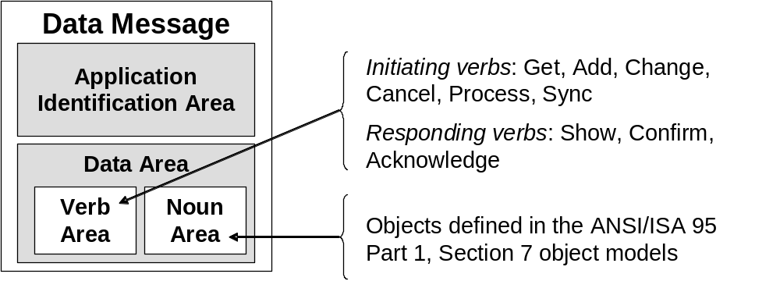
Figure 1 - Typical exchanged data set

Application identification area
The application identification area carries information that an application may need to know in order to communicate. The application information is used for the application layer of communication, such as confirmation of message processing. This information typically includes the electronic address of the sender, an indication of the confirmation requirement, and the date and time the message was created. The application identification area may also include other information required for identification and authentication of the messages. Figure 2 illustrates a typical layout for the application identification area.
Note: See the OAGIS (Open Applications Group Integration Specification) 8.0 specification for a format for the application identification area. The data exchange model defined in this document is consistent with the OAGIS specification, such that implementations of this specification can conform to the OAGIS specification.

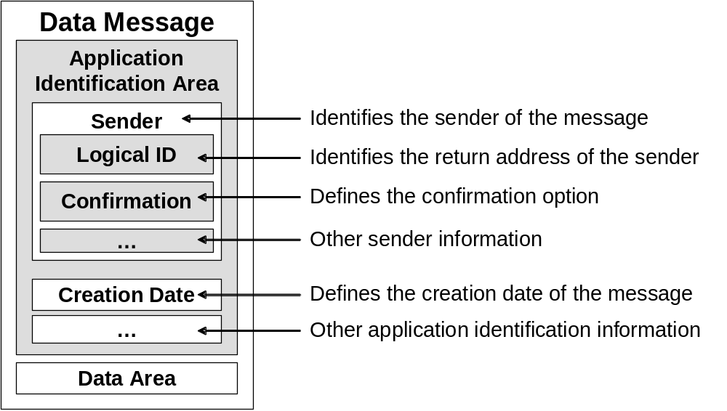
Figure 2 - Typical application identification information

Data Area
The data area in an exchanged message would contain a VERB area and a NOUN area.

Transaction verbs
The transaction models follow a VERB – NOUN model, where the VERB defines the action to be performed, or the response to a request. The NOUN defines one or more objects, as defined in the ISA-95 Part 1 object models. The VERB-NOUN combinations define messages or documents that have a unique and unambiguous meaning.
Table 1 lists the verbs defined in this specification.
Table 1 - Defined verbs
Verb | Description
Acknowledge | Acknowledgement of a request.
Add | Request to the owner of objects to add a new object.
Cancel | Request to the owner of objects to remove a new object.
Change | Request to the owner of objects to change a new object.
Confirm | Confirmation response to a request.
Get | Request to the owner of an object for information on the single object.
Process | Request from the owner of an object for the receiver to process the new object.
Show | Response to a GET.
Sync | Request from the owner of an object for the receiver to add, change, or remove an object.

Note 1: The processes on either side of the transaction are not defined in this technical specification.
Note 2: The defined verbs are based on the OAGIS 8.0 specification.

Transaction nouns
The NOUN defines one or more elements of the object model.
Table 2 lists the nouns defined in this specification and where there are defined in Part 2 of standard.
Table 2 - Defined nouns
Noun | Reference
Personnel Class | Part 2, Clauses 4.5.3 and 4.5.4
Person | Part 2, Clauses 4.5.1, 4.5.2 and 4.5.6
Qualification Test Specification | Part 2, Clause 4.5.5
Equipment Class | Part 2, Clauses 4.6.3 and 4.6.4
Equipment | Part 2, Clauses 4.6.1, 4.6.2 and 4.6.6
Capability Test | Part 2, Clause 4.6.5
Maintenance Request | Part 2, Clause 4.6.7
Maintenance Work Order | Part 2, Clause 4.6.8
Maintenance Response | Part 2, Clause 4.6.9
Material Class | Part 2, Clauses 4.7.1 and 4.7.2
Material Definition | Part 2, Clauses 4.7.3 and 4.7.4
Material Lot | Part 2, Clauses 4.7.5, 4.7.6, 4.7.7 and 4.7.9
QA Test | Part 2, Clause 4.7.8
Process Segment | Part 2, Clause 4.8
Production Capability | Part 2, Clause 4.3 and Clause 4.4
Product Definition | Part 2, Clause 4.9
Production Schedule | Part 2, Clause 4.10
Production Performance | Part 2, Clause 4.11

Transaction documents
The transactions are based on the assumption that the exchanged information (NOUN) is contained in a document of some form. The exact form of the documents is undefined in this specification, for example, the documents could be tab delimited files, XML files, electronic mail messages, or data in a named pipe.
The transactions assume the ability to send an empty or nearly empty document that identifies either a specific object (usually by ID) or a class of objects (by wildcard or property value definition). Figure 3 illustrates the exchange of documents in a typical transaction, where a document is sent with an identification of an object, and a document is returned with the object’s information.
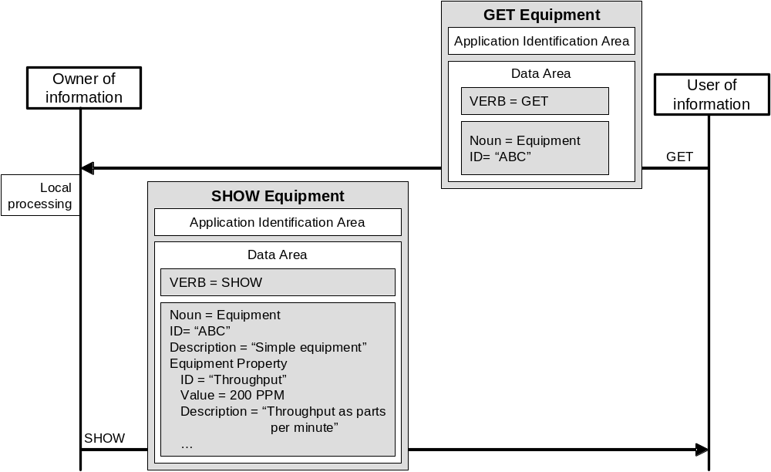
Figure 3 - Sample of exchanged documents in a transaction

Error Handling
Error handling at the application layer is through the confirmation element in the application identification area.
The application error handling is in addition to any communication layer error handling that may be provided by the infrastructure framework, web service, or middleware.
Confirmation is an option controlled by the sending business application. It is a request to the receiving application to send back a confirmation message/document to the sender.
The confirmation message/document must indicate the successful processing of the original message/document or return error conditions if the original message/document was not able to be processed. The error condition should include a description of the error.
A confirmation request has the values defined in Table 3.
Table 3 – Confirmation request options
Name | Description
Never | No confirmation requested.
OnError | Send back a confirmation only if an error has occurred.
Always | Always send a confirmation regardless of the local processing.

If an error occurs in the processing of a document in the receiving application and the sender set the confirmation element to either OnError or Always, then the receiving application must provide a CONFIRM document that references the original document’s ID. The CONFIRM document indicates that there was an error in the original document and carries the error messages from the receiving system.
The processing of the original sending system after receipt of the CONFIRM document indicating an error occurred in the original document is not defined in this technical specification.
For example, the CONFIRM verb is used when responding to a GET message/document when the owner of the information has detected an error in the request or in the identification of the object, and the sender has requested a confirmation on error. See Figure 4.

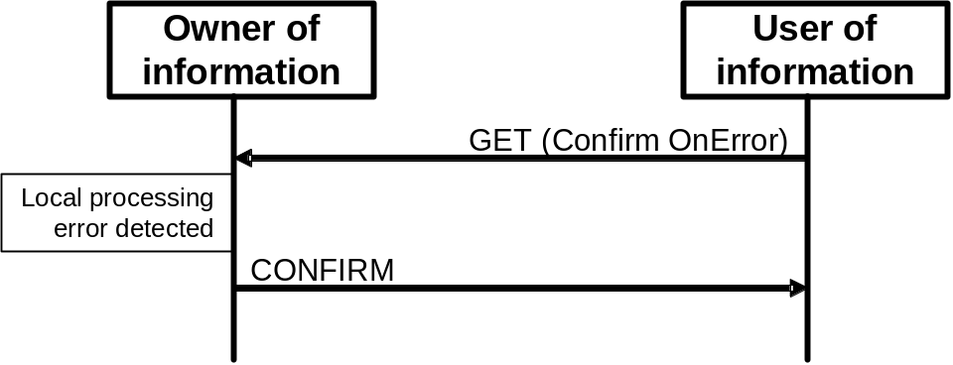
Figure 4 - Confirm verb
The CONFIRM is in addition to any communication layer error handling that may be provided by the network, infrastructure framework, or middleware.
The order of arrival of the CONFIRM and any other response message is not defined in this standard.
The error description, code, or text associated with a CONFIRM is contained in a CONFIRM noun, as shown in Figure 5.
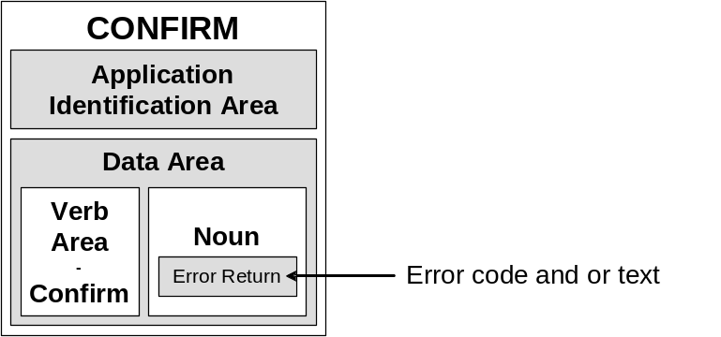
Figure 5 - Confirm Message

Request and response communication

GET individual object

GET Verb
The GET verb is used to communicate a request for information on an object or list of objects. The GET may be paired with many of the objects defined in this specification, see Table 23.
The response to the GET request is the SHOW verb.

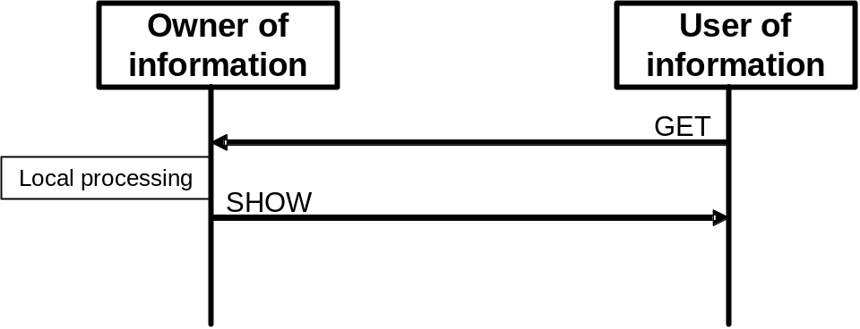
Figure 6 – GET and SHOW transaction
The GET is designed to retrieve one or more object and any contained objects by using the ID attribute.
Within a GET transaction, the ID of the requested object is passed to the owner of the information. Where a single ID is not sufficient identification, such as when a property of an object is needed, then the ID of the encapsulating object, and the ID or value of the encapsulated object (the property) is passed to the owner of the data. The identifying IDs are specified in the sections for each object type.
When a wildcard definition is used in the ID, then the GET returns a list of objects matching the wildcard specification. The GET may retrieve multiple objects such as all of the personnel classes. A GET with a wildcard does not require an exact match of the key fields in order to retrieve information.

Wildcards
The GET may contain wildcard values for object and property identifications.
In a wildcard value the following special character rules apply:
- “*” – Indicates zero or more characters, any character is acceptable
Example: The wildcard “ABC*” would match “ABC”, “ABCD”, “ABCDEF”, “ABC@4!*“, but not “ABDDEF”
- “%” – Indicates one or more characters, any character is acceptable
Example: The wildcard “ABC%” would match “ABCD”, “ABCDEF”, “ABC^4^*“, but not “ABC”
- “?” – Indicates zero or one characters at the specified position, any character is acceptable
Example: The wildcard “ABC?” would match “ABCX”, “ABCD”, “ABC!“, “ABC”, but not “ABCDE” or “ABDC”
Object identifications may not contain any of the wildcard characters: “*”, “%”, and “?”.
Figure 7 illustrates a GET transaction with a wildcard specified. The owner of the information returns a list of objects matching the wildcard specification.
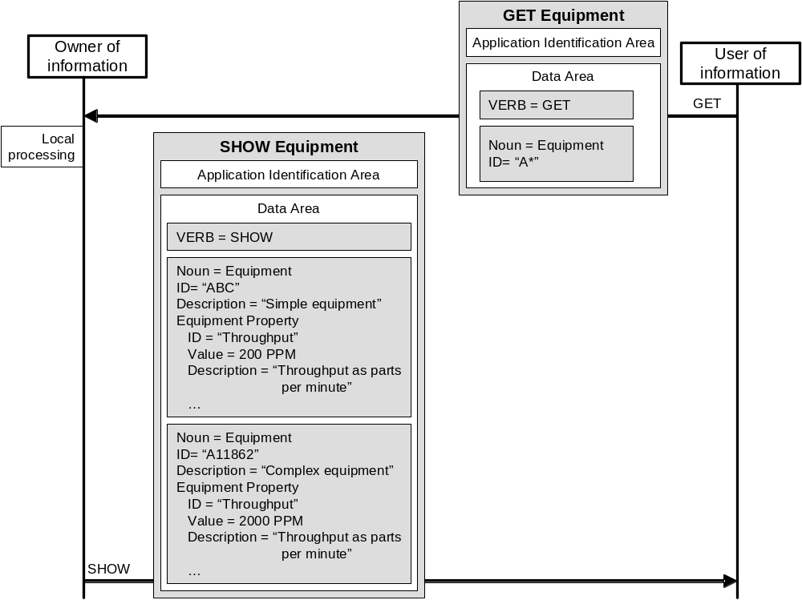
Figure 7- GET with wildcard and SHOW response

SHOW Verb
The SHOW verb is used when responding to a GET message. Figure 8 illustrates a GET and SHOW transaction with a CONFIRM always option.

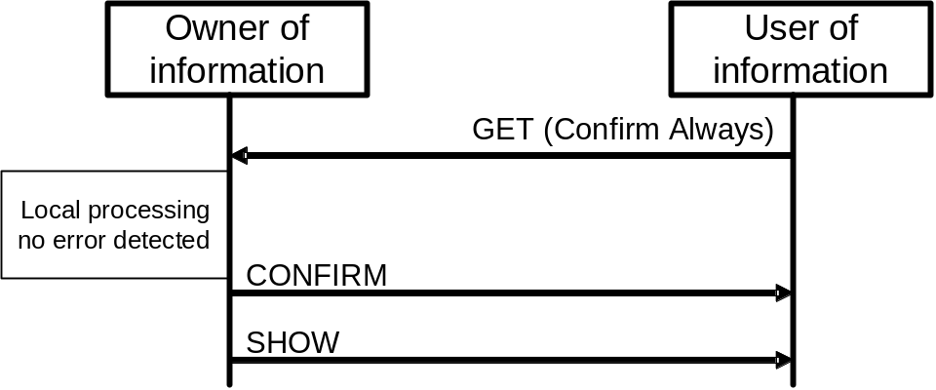
Figure 8 - GET and SHOW transaction with a CONFIRM always
Note: The order of arrival of the CONFIRM and any other response message is not defined in this standard.

ADD an object
The ADD verb is used to initiate the adding of a data entity to another application. ADD is used when the sender of the message is not the owner of the data, but is sending a request for the information to be created by the system that is the owner of the data.
An example of this is an ADD Equipment message, where the equipment instance is created in an application which is not the owner of the equipment model data.

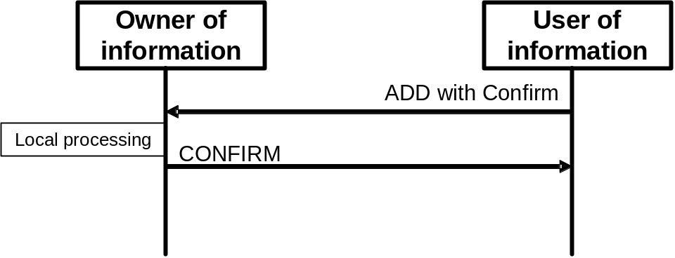
Figure 9 - ADD with a Confirm

Object identification in an ADD
- An ADD with an empty ID attribute specifies that the owner of the information is to create the object and assign an ID.
- An ADD with an ID defines a suggested ID for the object. The owner of the information creates the object and assigns an ID.
- An ADD with CONFIRM will return the ID of the added object in the CONFIRM noun area.
- An ADD with a wildcard ID specification is not valid and returns an error.

CHANGE an object
The CHANGE verb is used when the sender of the message is not the owner of the data, but is sending a request for the data to be changed.
An example of this is a CHANGE Person message, where the personnel information, such as a qualification test, is changed by a system which is not the owner of the personnel model data.

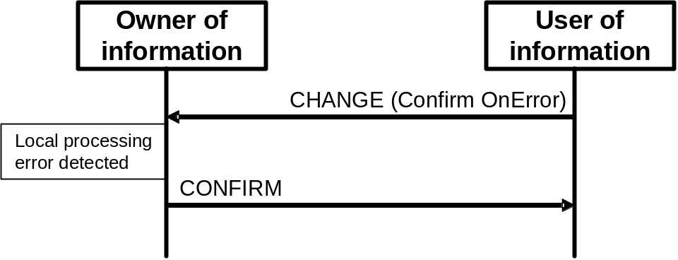
Figure 10 - CHANGE command with confirm OnError set

Object identification in a CHANGE
- A CHANGE with an ID specifies that the single identified object is to be modified.
- A CHANGE with a wildcard ID specifies that all objects matching the wildcard are to be modified.
- A CHANGE with an empty ID is not valid and returns an error.

CANCEL an object
The CANCEL verb is used when the sender of the message is not the owner of the data, but is sending a request for the data to be canceled.
Note: Because the CANCEL is not sent by the owner of the data, a term such as DELETE can often not fully convey the business meaning and required processing associated with the action.
An example of this is a CANCEL MaterialLot message, where an application indicates that a material lot is no longer valid (or available), but the application is not the owner of the material model data.

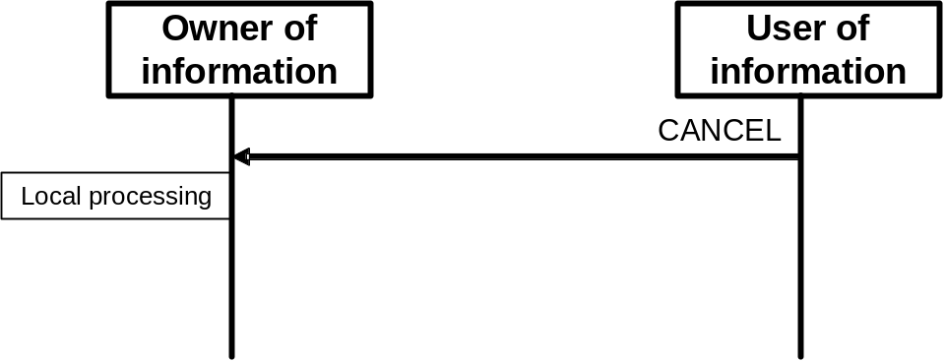
Figure 11 - CANCEL command

Object identification in a CANCEL
- A CANCEL with an ID specifies that the single identified object is to be canceled.
- A CANCEL with a wildcard ID specifies that all objects matching the wildcard are to be canceled.
- A CANCEL with an empty ID is not valid and returns an error.

Publish and subscribe transactions
A publish-subscribe model is used when the owner of the information publishes changes to the information to systems that have subscribed to the information. The transaction protocol does not include the definition of the subscription mechanism. It is assumed that the subscription is setup outside the scope of these transactions
Example: The subscription could be “hard-coded” into the application.
Example: The subscription could be setup as a configurable option with a list of subscribers configured in the publisher.
Example: The subscription could be made through an interactive subscription service.

PROCESS an object
A PROCESS verb is sent by the owner of the data. The PROCESS verb is used to request processing of the associated noun by the receiving application. In a typical exchange scenario a PROCESS message is considered to be the equivalent of a formal business command. For example, the sending of a production schedule to a site indicates that the schedule is to be executed.
The response to a PROCESS is an ACKNOWLEDGE. The ACKNOWLEDGE verb is only used to acknowledge the application receipt of a PROCESS request. The ACKNOWLEDGE message may return the original or modified data.

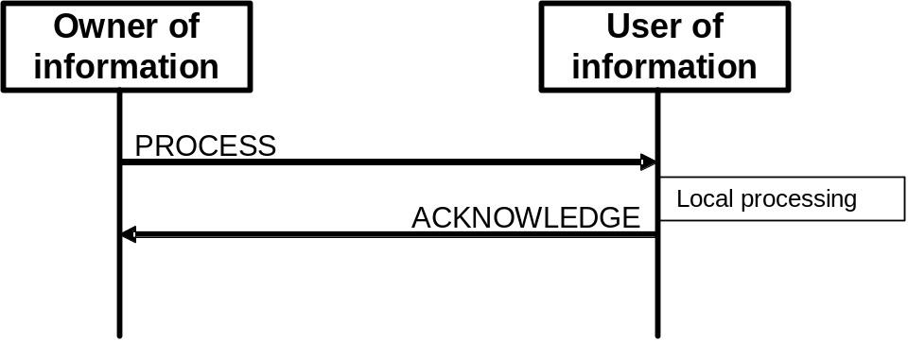
Figure 12 - PROCESS Command
An example of this is an ACKNOWLEDGE Production Schedule message, where a PROCESS Production Schedule message has been received and the corresponding business application acknowledges the receipt of the Production Schedule and responds with an acceptance.
An ACKNOWLEDGE contains an element with one of the following additional definitions: Accepted, Rejected, or Modified.
Table 4 – Acknowledge additional element
ACKNOWLEDGE ELEMENT | DEFINITION
ACCEPTED | The information was accepted by the receiver of the information and was processed according to the business rules of the receiver.
REJECTED | The information was rejected by the receiver of the information and was not processed by the receiver.
MODIFIED | The information was accepted by the receiver of the information but was modified for correct processing, the modified data is returned with the ACKNOWLEDGE.

SYNC information
The SYNC verb is used when the owner application of the data is passing or publishing that information or change in information to other applications. SYNC is short for synchronize, and implies synchronized data; it does not mean synchronous communications. SYNC is used when the receiver of the information does not own the data.
There should only be one application that sends SYNC messages for any specific element of information.
The owner of the information sends the SYNC verb. The SYNC verb contains one of the following modifiers: ADD, CHANGE, or DELETE.
This verb is commonly used when mass changes are necessary or when a publish and subscribe mechanism is used in the integration architecture.

CONFIRM an exchange
The response to SYNC verb may be a CONFIRM message, see Figure 13. The CONFIRM message is defined in clause 4.3.
The CONFIRM verb is used to respond to a request to confirm the receipt of information by the receiving system. The request for confirmation is set by the sending application. The CONFIRM conveys the result of the original request, it indicates whether or not the message was understood and was successfully processed.

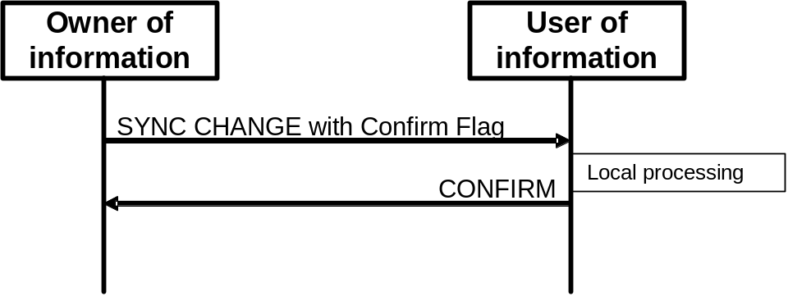
Figure 13- SYNC CHANGE transaction with Confirm set

SYNC ADD an object
A SYNC ADD verb is sent by the owner of the information. The SYNC ADD indicates that the owner of the information has added a new object and the receivers should either synchronize the received information with their local storage or process the object.

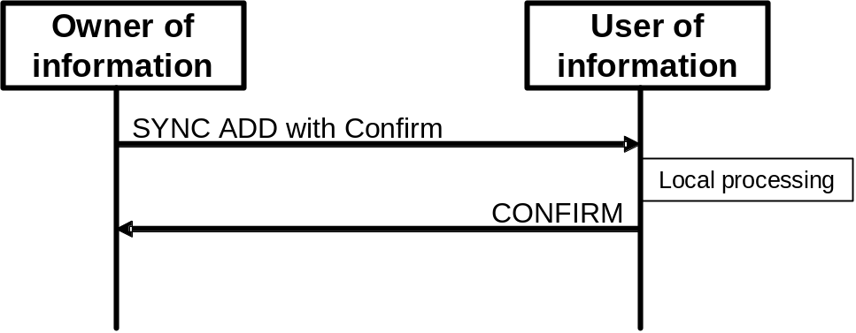
Figure 14 - SYNC ADD transaction
An example of this may be a SYNC ADD on a QA TEST object, which indicates the definition of a new QA test.

Object identification in a SYNC ADD
- A SYNC ADD may define one or more objects.
- A SYNC ADD with an undefined ID attribute is an error
- A SYNC ADD with a wildcard ID attribute is an error.

SYNC CHANGE an object
A SYNC CHANGE verb is sent by the owner of the information. The SYNC CHANGE indicates that the owner of the information has changed the object and the receivers should either synchronize the received information with their local storage or process the changed object.
Figure 15 - SYNC CHANGE transaction with CONFIRM set
An example of a SYNC CHANGE may be a SYNC CHANGE on a MATERIAL CLASS object, which indicates a change in the material class or a property of the material class.

Object identification in a SYNC CHANGE
- A SYNC CHANGE may modify one or more objects.
- A SYNC CHANGE with an undefined ID attribute is an error.
- A SYNC CHANGE with a wildcard ID specifies changes to all objects matching the wildcard specification.

SYNC DELETE an object
A SYNC DELETE verb is sent by the owner of the information. The SYNC DELETE indicates that the owner of the information has deleted the object and the receivers should either synchronize the received information with their local storage or process the changed object.
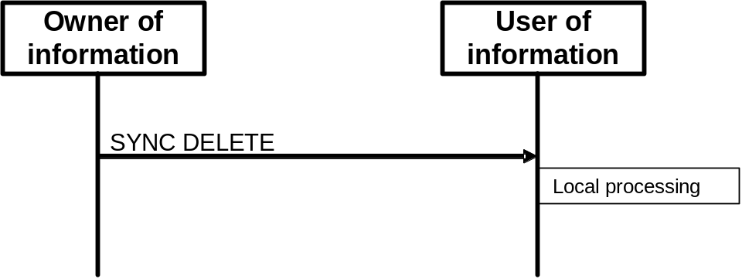
Figure 16 - SYNC DELETE transaction with no CONFIRM

Object identification in a SYNC DELETE
- A SYNC DELETE may delete one or more objects.
- A SYNC DELETE with an undefined ID attribute is an error.
- A SYNC DELETE with a wildcard ID will specify a delete of all objects matching the wildcard specification.

Transactions

Personnel model
The transaction definitions assume that information may be accessed from any of three starting points: personnel class, person, or qualification test, as identified by the dotted collections in the figure.
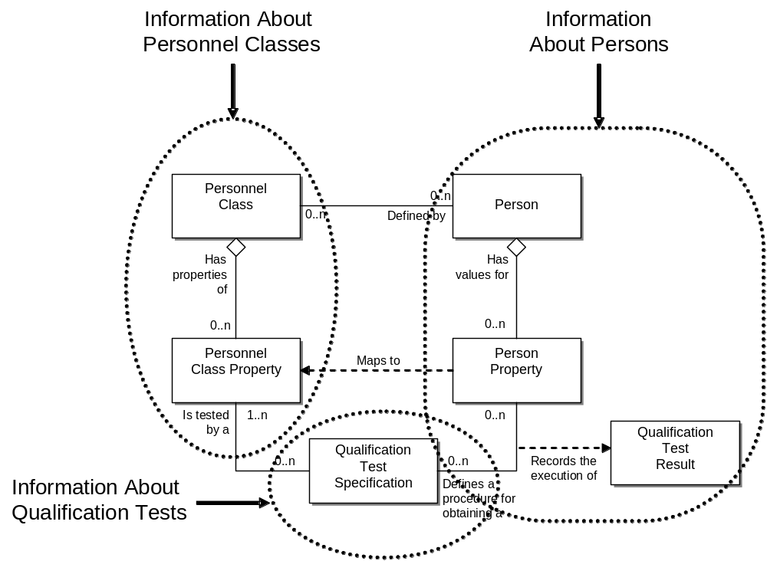
Figure 17 - Object grouping for the personnel model
For example, transactions may be:
Get Personnel Class, Get Person, Get Qualification Test

Personnel Class
This contains information about personnel classes, or personnel classes and their personnel class properties. The returned information does not contain the person objects associated with the personnel class, but only the IDs of the persons belonging to the class.
The following verbs are defined for a personnel class noun: GET, ADD, CHANGE, CANCEL, SYNC ADD, SYNC CHANGE, and SYNC DELETE.
The information returned from a Get is defined in the table below.
Table 5 - Personnel class Get definitions
Verb | Personnel  Class ID | Property ID and Value | Returns
Get | ID specified | <empty> | All attributes about the personnel class, the list of associated person IDs belonging to the personnel class, and all properties of the personnel class identified.
Get | ID specified | Property ID & Value Specified | All attributes about the personnel class and the list of associated person IDs belonging to the subset identified by the property
Get | <empty> | <empty> | All attributes about all personnel classes, all properties of all personnel classes, and the list of associated person IDs of all classes.
Get | Wildcard specified | <empty> | All attributes about the personnel classes identified by the wildcard, all personnel class properties for the classes, and the list of associated person IDs belonging to the classes.
Get | Wildcard specified | Property ID & Value Specified | All attributes about the personnel subsets identified by the wildcard and the property values, and the list of associated person IDs belonging to the subsets.

Person
This contains information about persons and their person properties. The returned information does not contain the personnel class objects associated with the person, but only the IDs of the personnel classes the person belongs to.
The following verbs are defined for a person noun: Get, Add, Change, Cancel, Sync Add, Sync Change, and Sync Delete.
The information returned from a Get is defined in the table below.
Table 6 - Person Get definitions
Verb | Person  Class ID | Property ID | Returns
Get | ID specified | <empty> | All attributes about the person, the list of associated personnel class IDs the person belongs to, all properties of the person identified, and all qualification test results of the person.
Get | ID specified | Property ID specified | All attributes about the person, list of associated personnel class IDs the person belongs to, and all qualification test results for the identified property.
Get | <empty> | <empty> | All attributes about all persons, all properties of all persons, the list of associated personnel class IDs of all persons, and all qualification test results of the person.
Get | Wildcard specified | <empty> | All attributes about the persons identified by the wildcard, all person properties for the persons, the list of associated personnel class IDs of all persons, and all qualification test results of the person.
Get | Wildcard specified | Property ID Specified | All attributes about the person identified by the wildcard, the value of the property, and all qualification test results for the specified property.

Qualification Test
This contains information about qualification tests. The returned information contains the identification of the tested personnel class properties, and the identification of the person properties.
The following verbs are defined for a qualification test noun: Get, ADD, Change, Cancel, Sync Add, Sync Change, and Sync Delete.
The information returned from a Get is defined in the table below.
Table 7 - Qualification Test Get definitions
Verb | Qualification Test ID | Returns
Get | ID specified | All attributes about the qualification test specification, the list of associated personnel class properties referenced by the test, and the list of all person properties referenced by the test.
Get | <empty> | All attributes about all qualification test specification, the list of associated personnel class properties referenced by all tests, and the list of all person properties referenced by the tests.
Get | Wildcard specified | All attributes about all qualification test specification identified by the wildcard, the list of associated personnel class properties referenced by all tests, and the list of all person properties referenced by the tests.

Equipment
The transaction definitions assume that information may be accessed from any of three starting points: equipment class, equipment, or equipment capability test, as identified by the dotted collections in the figure.

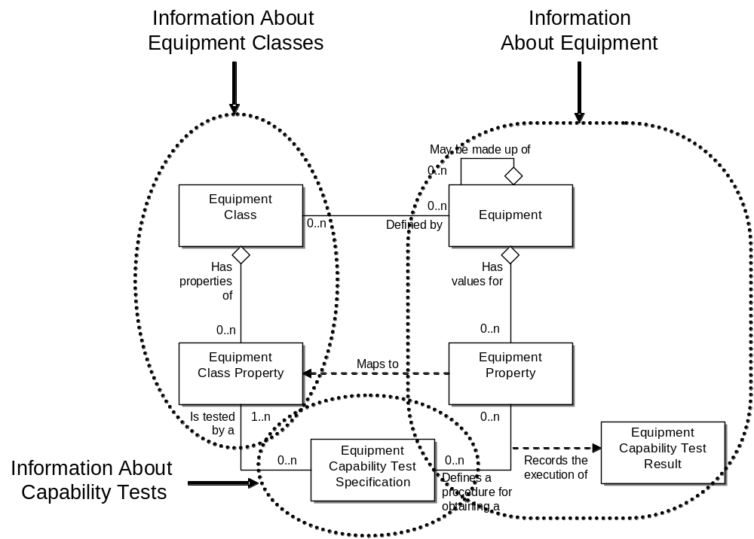
Figure 18 - Object grouping for the equipment model
For example, transactions may be:
Get Equipment Class, Get Equipment, Get Equipment Capability Test.

Equipment Class
This contains information about equipment classes, or equipment classes and their equipment class properties. The returned information does not contain the equipment objects associated with the equipment class, but only the IDs of the equipment belonging to the class.
The following verbs are defined for an equipment class noun: Get, Add, Change, Cancel, Sync Add, Sync Change, and Sync Delete.
The information returned from a Get is defined in the table below.
Table 8 - EquipmentClass Get definitions
Verb | Equipment  Class ID | Property ID and Value | Returns
Get | ID specified | <empty> | All attributes about the equipment class, the list of associated equipment IDs belonging to the equipment class, and all properties of the equipment class identified.
Get | ID specified | Property ID & Value Specified | All attributes about the equipment class and the list of associated equipment IDs belonging to the subset identified by the property
Get | <empty> | <empty> | All attributes about all equipment classes, all properties of all equipment classes, and the list of associated equipment IDs of all classes.
Get | Wildcard specified | <empty> | All attributes about the equipment classes identified by the wildcard, all equipment class properties for the classes, and the list of associated equipment IDs belonging to the classes.
Get | Wildcard specified | Property ID & Value Specified | All attributes about the equipment subsets identified by the wildcard and the property values, and the list of associated equipment IDs belonging to the subsets.

Equipment
This contains information about equipment and their equipment properties. The returned information does not contain the equipment class objects associated with the equipment, but only the IDs of the equipment classes the person belongs to.
The following verbs are defined for an equipment noun: Get, ADd, Change, Cancel, Sync Add, Sync Change, and Sync Delete.
The information returned from a Get is defined in the table below.
Table 9 - Equipment Get definitions
Verb | Equipment  Class ID | Property ID | Returns
Get | ID specified | <empty> | All attributes about the equipment, the list of associated equipment class IDs the equipment belongs to, all properties of the equipment identified, all capability test results of the equipment, and equipment all IDs of all contained equipment elements.
Get | ID specified | Property ID specified | All attributes about the equipment, list of associated equipment class IDs the equipment belongs to, all capability test results for the identified property, and all equipment IDs of all contained equipment elements.
Get | <empty> | <empty> | All attributes about all equipment, all properties of all equipment, the list of associated equipment class IDs of all equipment, all capability test results of the equipment, and all contained equipment elements.
Get | Wildcard specified | <empty> | All attributes about the equipment identified by the wildcard, all equipment properties for the equipment, the list of associated equipment class IDs of all equipment, all capability test results of the equipment, and all contained equipment elements.
Get | Wildcard specified | Property ID Specified | All attributes about the equipment subset identified by the wildcard and the property value, the property value, all capability test results for the specified property, and all contained equipment elements.

Capability Test
This contains information about capability tests. The returned information contains the identification of the tested equipment class properties, and the identification of the equipment properties.
The following verbs are defined for a capability test noun: Get, Add, Change, Cancel, Sync Add, Sync Change, and Sync Delete.
The information returned from a Get is defined in the table below.
Table 10 - Capability Test Get definitions
Verb | Capability Test ID | Returns
Get | ID specified | All attributes about the capability test specification, the list of associated equipment class properties referenced by the test, and the list of all equipment properties referenced by the test.
Get | <empty> | All attributes about all capability test specification, the list of associated equipment class properties referenced by all tests, and the list of all equipment properties referenced by the tests.
Get | Wildcard specified | All attributes about all capability test specification identified by the wildcard, the list of associated equipment class properties referenced by all tests, and the list of all equipment properties referenced by the tests.

Maintenance
The transaction definitions assume that information on Maintenance Requests, Maintenance Responses, and Maintenance Work Orders may be sent separately.

Maintenance Requests
A request for maintenance is represented as a maintenance request. A maintenance request is made against specific equipment. There may be many outstanding maintenance requests against a piece of equipment.
The following verbs are defined for a maintenance request noun: Get, Process, Sync Add, Sync Change, and Sync Delete.
The information returned from a Get is defined in the table below.
Table 11 - Maintenance Request Get definitions
Verb | Maintenance Request ID | Returns
Get | ID specified | All information for the specified maintenance request.
Get | <empty> | All information on all maintenance requests.
Get | Wildcard specified | All information on all maintenance requests identified by the wildcard.

Maintenance Response
A maintenance response contains the response to a maintenance request.
The following verbs are defined for a maintenance response noun: Get, Process, Sync Add, Sync Change, and Sync Delete.
The information returned from a Get is defined in the table below.
Table 12 - Maintenance Response Get definitions
Verb | Maintenance Response ID | Returns
Get | ID specified | All information for the specified maintenance response.
Get | <empty> | All information on all maintenance responses.
Get | Wildcard specified | All information on all maintenance responses identified by the wildcard.

Maintenance Work Order
Work done against a maintenance request is represented as a maintenance work order. Zero or more maintenance work orders may be generated from a maintenance request.
The following verbs are defined for a maintenance work order noun: Get, Process, Sync Add, Sync Change, and Sync Delete.
The information returned from a Get is defined in the table below.
Table 13 - Maintenance Work Order Get definitions
Verb | Maintenance Request ID | Returns
Get | ID specified | All information for the specified maintenance work order.
Get | <empty> | All information on all maintenance work orders.
Get | Wildcard specified | All information on all maintenance work orders identified by the wildcard.

Material
The transaction definitions assume that information may be accessed from any of four starting points: material class, material definition, material lot, or QA tests, as identified by the dotted collections in the figure.
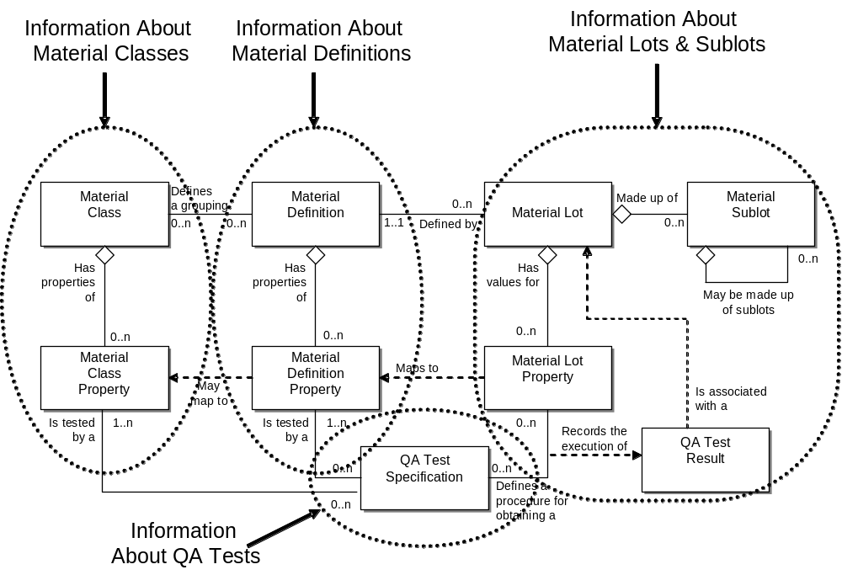
Figure 19 - Object grouping for the material model
For example, transactions may be:
Get Material Class, Get Material Lot, Get QA Test.

Material Class
This contains information about material classes, or material classes and their material class properties. The returned information does not contain the material definitions associated with the material class, but only the IDs of the material definitions belonging to the class.
The following verbs are defined for a material class noun: Get, Add, Change, Cancel, Sync Add, Sync Change, and Sync Delete.
The information returned from a Get is defined in the table below.
Table 14 - Material Class Get definitions
Verb | Material  Class ID | Property ID and Value | Returns
Get | ID specified | <empty> | All attributes about the material class, the list of associated material definition IDs belonging to the material class, and all properties of the material class identified.
Get | ID specified | Property ID & Value Specified | All attributes about the material class and the list of associated material definition IDs belonging to the subset identified by the property
Get | <empty> | <empty> | All attributes about all material classes, all properties of all material classes, and the list of associated material definition IDs of all classes.
Get | Wildcard specified | <empty> | All attributes about the material classes identified by the wildcard, all material class properties for the classes, and the list of associated material definition IDs belonging to the classes.
Get | Wildcard specified | Property ID & Value Specified | All attributes about the material subsets identified by the wildcard and the property values, and the list of associated material definition IDs belonging to the subsets.

Material Definition
This contains information about material definitions, or material definitions and their material definitions properties. The returned information does not contain the material lots associated with the material definition, but only the IDs of the material lots.
The following verbs are defined for a material definition noun: Get, Add, Change, Cancel, Sync Add, Sync Change, and Sync Delete.
The information returned from a Get is defined in the table below.
Table 15 - Material Definition Get definitions
Verb | Material  Definition ID | Property ID and Value | Returns
Get | ID specified | <empty> | All attributes of the material definition, the list of associated material class IDs belonging to the material definition, the list of all material lot IDs belonging to the material definition, and all properties of the material definition identified.
Get | ID specified | Property ID & Value Specified | All attributes of the material definition, the list of associated material class IDs belonging to the subset identified by the property, and all material lot IDs of the material lots belonging to the material definition.
Get | <empty> | <empty> | All attributes of all material definition, all properties of all material definition, the list of associated material class IDs of all classes, and the list of all associated material lots IDs.
Get | Wildcard specified | <empty> | All attributes of the material definition identified by the wildcard, all material definition properties, the list of associated material class IDs belonging to the definitions, and all material lot IDs of the material definitions.
Get | Wildcard specified | Property ID & Value Specified | All attributes of the material definitions identified by the wildcard and the property value, the list of associated material class IDs belonging to the definitions, and the list of material lot IDs belonging to the definitions.

Material Lot
This contains information about material lots and their properties.
The following verbs are defined for a material lot noun: Get, Add, Change, Cancel, Sync Add, Sync Change, and Sync Delete.
The information returned from a Get is defined in the table below.
Table 16 - Material Lot Get definitions
Verb | Material  Lot ID | Property ID | Returns
Get | ID specified | <empty> | All attributes of the material lot, the list of properties associated with the material lot, the list of material sublots and all attributes of the material sublots, and the list of all QA Test Results associated with the material lot.
Get | ID specified | Property ID specified | All attributes of the material lot, the identified property of the material lot, and all QA Test Results associated with the specified property.
Get | <empty> | <empty> | All attributes of all material lots, the list of properties associated with the material lot, the list of material sublots and all attributes of the material sublots, and the list of all QA Test Results associated with the material lot.
Get | Wildcard specified | <empty> | All attributes of all material lots identified by the wildcard, the list of properties associated with the material lots, the list of material sublots and all attributes of the material sublots, and the list of all QA Test Results associated with the material lot.
Get | Wildcard specified | Property ID Specified | All attributes of all material lots identified by the wildcard, the property value, and the list of all QA Test Results associated with the specified property.

QA Test
This contains information about QA tests. The returned information contains the identification of the tested material definition properties, material class properties, and the identification of the tested material lot properties.
The following verbs are defined for a QA Test noun: Get, Add, Change, Cancel, Sync Add, Sync Change, and Sync Delete.
The information returned from a Get is defined in the table below.
Table 17 - QA Test Get definitions
Verb | QA Test ID | Returns
Get | ID specified | All attributes about the QA test specification, the list of all associated material class and material definition properties referenced by the test.
Get | <empty> | All attributes about all QA test specifications, the list of all associated material class and material definitions properties referenced by all tests.
Get | Wildcard specified | All attributes about all QA test specifications identified by the wildcard, the list of associated material class and material definition properties referenced by all tests.

Process Segment
A process segment is a logical grouping of personnel resources, equipment resources, and material required to carry out a production step. A process segment usually defines the needed classes of personnel, equipment, and material, but it may define specific resources, such as specific equipment needed. Process segment may define the quantity of the resource needed.
The process segment model is hierarchical with process segments containing process segments and personnel, equipment, and material specification information.
The following verbs are defined for a process segment noun: Get, Add, Change, Cancel, Sync Add, Sync Change, and Sync Delete.
The information returned from a Get is defined in the table below.
Table 18 – Process Segment Get definitions
Verb | Process Segment ID | Returns
Get | ID specified | All attributes about the process segment, the list of all associated personnel, equipment, and material segment requirements, all process segment parameters, all process segment dependencies,
Get | <empty> | All attributes about all process segments, the list of all associated personnel, equipment, and material segment requirements, all process segment parameters, all process segment dependencies,
Get | Wildcard specified | All attributes about process segments that match the wildcard, the list of all associated personnel, equipment, and material segment requirements, all process segment parameters, all process segment dependencies,

Production Capability
The production capability information is the collection of information about all resources for production for selected times. This is made up of information about equipment, material, personnel, and process segments. It describes the names, terms, statuses, and quantities of which the manufacturing control system has knowledge. The presumption is that a Level 3 function is the owner of the production capability information.
The production capability model is hierarchical with production capabilities containing process segment capabilities and personnel, equipment, and material capability information.
The following verbs are defined for a production capability noun: GET, ADD, CHANGE, and CANCEL.
Production capability is a snapshot, in time, of the available, unattainable, or committed capability. Specifying the information to be returned from a Get may involve values in multiple fields. Each field definition restricts the returned information.
Table 19 – Production Capability Element definitions for GET verb
Production Capability Element | Returns
StartTime | Specifies production capability information for times after, and including the start time. If not specified then the responder may select the StartTime.
EndTime | Specifies production capability information for times before, and including, the end time. If not specified then the responder may select the EndTime.
Location | Specifies production capability information for the specified location. (e.g. A process cell, work center, production line, area, site, …) If not specified then the responder may select the Location.
CapabilityType | Specifies the type of production capability information to be returned. If not specified, then the responder may select the CapabilityType information returned.
PersonnelCapability / PersonnelClassID | May specify a wildcard or a personnel class id. If included, then it specifies the personnel class(es) for the returned PersonnelCapability.
PersonnelCapability / PersonID | May specify a wildcard or a person id. If included, then it specifies the person(s) for the returned PersonnelCapability.
EquipmentCapability / EquipmentClassID | May specify a wildcard or an equipment class id. If included, then it specifies the equipment class(es) for the returned PersonnelCapability.
EquipmentCapability / EquipmentID | May specify a wildcard or an equipment id. If included, then it specifies the equipment for the returned PersonnelCapability.
MaterialCapability / MaterialClassID | May specify a wildcard or a material class id. If included, then it specifies the material class(es) for the returned PersonnelCapability.
MaterialCapability / MaterialDefinitionID | May specify a wildcard or a material definition id. If included, then it specifies the material definitions(s) for the returned PersonnelCapability.
MaterialCapability / MaterialLotID | May specify a wildcard or a material lot id. If included, then it specifies the material lot(s) for the returned PersonnelCapability.
MaterialCapability / MaterialLotID | May specify a wildcard or a material sublot id. If included, then it specifies the material sublot(s) for the returned PersonnelCapability.
ProcessSegmentCapabilityID | May contain a wildcard or a process segment identification. If included, then it specifies that ProcessSegmentCapability should only be returned for the specified process segment.
ProcessSegmentCapability / PersonnelClassID | May specify a wildcard or a personnel class id. If included, then it specifies the personnel class(es) for the returned ProcessSegment/PersonnelCapability.
ProcessSegmentCapability / PersonID | May specify a wildcard or a person id. If included, then it specifies the person(s) for the returned ProcessSegment/PersonnelCapability.
ProcessSegmentCapability / EquipmentClassID | May specify a wildcard or an equipment class id. If included, then it specifies the equipment class(es) for the returned ProcessSegment/PersonnelCapability.
ProcessSegmentCapability / EquipmentID | May specify a wildcard or an equipment id. If included, then it specifies the equipment for the returned vPersonnelCapability.
ProcessSegmentCapability / MaterialClassID | May specify a wildcard or a material class id. If included, then it specifies the material class(es) for the returned ProcessSegment/PersonnelCapability.
ProcessSegmentCapability / MaterialDefinitionID | May specify a wildcard or a material definition id. If included, then it specifies the material definitions(s) for the returned ProcessSegment/PersonnelCapability.
ProcessSegmentCapability / MaterialLotID | May specify a wildcard or a material lot id. If included, then it specifies the material lot(s) for the returned ProcessSegment/PersonnelCapability.
ProcessSegmentCapability / MaterialLotID | May specify a wildcard or a material sublot id. If included, then it specifies the material sublot(s) for the returned ProcessSegment/PersonnelCapability.

Product Definition
A product definition contains a listing of the exchanged information about a product. The information is used in a set of product segments. A product definition has a reference to a bill of materials, a product production rule, and a bill of resources. It contains the manufacturing bill and the product segment definitions.
The only verbs defined for a product definition are GET and PROCESS.
Table 20 – Product Definition Get definitions
Verb | Product Definition ID | Returns
Get | ID specified | All information on the product definition is returned,
Get | <empty> | All information on all product definitions is returned.
Get | Wildcard specified | All information on all product definitions which match the wildcard is returned.

Production Schedule
A production schedule contains a set of production requests, each request specifying production of a main product. The presumption is that a Level 4 function is the owner of the production schedule information.
The only verbs defined for a production schedule are GET and PROCESS.
Table 21 – Production Schedule definitions for GET verb
Production Schedule Element | Returns
StartTime | Specifies the production schedule information for times after, and including the start time. Should be specified in the GET, otherwise the responder may select the StartTime.
EndTime | Specifies the production schedule information for times before, and including, the end time. If not specified then the responder may select the EndTime.
Location | Specifies the production schedule information for the specified location. (e.g. A process cell, work center, production line, area, site, …). If not specified then the responder may select the Location.
ProductionSegment / ProoductProductionRule | Specifies one or more product segments and the Product Production Rule identifying the product, and returns the schedules for the specified products.

Production Performance
A production response contains a set of production responses. Production responses contain the items reported back to the business system, at the end of production or during production. The presumption is that a Level 3 function is the owner of the production performance information.
The following verbs are defined for a production capability noun: GET, ADD, CHANGE, and CANCEL.
Production performance is a snapshot, in time, of the available, unattainable, or committed capability. Specifying the information to be returned from a GET may involve values in multiple fields. Each field definition restricts the returned information.
Table 22 – Production Performance definitions for GET verb
Production Performance Element | Returns
StartTime | Specifies production performance information for times after, and including the start time. Should be specified in the GET, otherwise the responder may select the StartTime.
EndTime | Specifies production performance information for times before, and including, the end time. If not specified then the responder may select the EndTime.
Location | Specifies production performance information for the specified location. (e.g. A process cell, work center, production line, area, site, …). If not specified then the responder may select the Location.
ProductionPerformance / ProductionResponse / ProductionRequestID | Specifies the production performance information associated with the specified production request.
ProductionPerformance / ProductionResponse / ProductProductionRuleID | Specifies the production performance information associated with the specified product production rule.
ProductionPerformance / ProductionResponse / SegmentResponse / ProcessSegmentID | Specifies the production performance information associated with the specified process segment.
ProductionPerformance / ProductionResponse / SegmentResponse / ProductSegmentID | Specifies the production performance information associated with the specified product segment.

Defined Transactions
Table 23 summarizes the standard verb and noun relationship. Each of the elements in the table is defined in previous sections. Suppliers of systems should use Table 23 to define their supported transactions.
Table 23- Verb and noun relationship
Verb  Object Group | GET | ADD, CHANGE, CANCEL | PROCESS | SYNC ADD | SYNC CHANGE | SYNC DELETE
Personnel Class | YES | YES | no | YES | YES | YES
Person | YES | YES | no | YES | YES | YES
Qualification Test | YES | YES | no | YES | YES | YES
Equipment Class | YES | YES | no | YES | YES | YES
Equipment | YES | YES | no | YES | YES | YES
Capability Test | YES | YES | no | YES | YES | YES
Maintenance Request | YES | no | YES | YES | YES | YES
Maintenance Work Order | YES | no | YES | YES | YES | YES
Maintenance Response | YES | no | YES | YES | YES | YES
Material Class | YES | YES | no | YES | YES | YES
Material Definition | YES | YES | no | YES | YES | YES
Material Lot | YES | YES | no | YES | YES | YES
QA Test | YES | YES | no | YES | YES | YES
Process Segment | YES | YES | no | YES | YES | YES
Production Capability | YES | no | YES | no | no | no
Product Definition | YES | no | YES | YES | YES | YES
Production Schedule | YES | no | YES | no | no | no
Production Performance | YES | no | YES | no | no | no

Annex A – Questions on the use of transactions
A.1 Different systems will have different IDs for the same objects. The GET verb and others use IDs to identify the object. Which ID is used and how does any translation occur?
On a project basis there must be an agreement which system’s ID to use. The translation can occur at any of three spots, either side, or in a middleware system.
This gets even more interesting when there are more than two systems. In that situation it may be beneficial to designate a system as the repository of the mapping information, and to allow exchanging of the alternate names as properties of the object.
For example, if there is a maintenance system, production system, and business system which all have knowledge of the same object, but each have different IDs, then one system can maintain properties of “Maintenance ID”, “Production ID”, and “Business ID”. The GET verb can be used with a specified property name to return the global ID and each mapping.
A.2 Are these database or message transactions?
This technical specification defines message transactions between cooperating systems, and not database transactions. It is unfortunate that the term “transaction” is used to mean different things in different contexts.
A.3 How are rollbacks handled?
Any rollbacks would be handled by the owner of the data. Each transactions may have a CONFIRM set, and the receiver of the response would be responsible for determining what action to take.
A.4 Why should CONFIRM be used in a SYNC?
Typically CONFIRM is not used with SYNC, but in some situations this may be required and the transaction definition allows its use. It may be required when the information is a critical piece of information which must be shared with a limited number subscribers.
However, it should be used with care because:
- If many clients are subscribed, the publisher may be overwhelmed by the CONFIRM messages
- Unless linked to the subscribe mechanism, the publisher will not be able to know if any client failed to confirm the SYNC
- Even if publisher detects that one client failed to properly process the SYNC message (either sent a CONFIRM error message or sent nothing) there may not be much it can do.

Annex B – Bibliography and References
OAGIS - (Open Applications Group Integration Specification) – see www.openapplications.org

